


BROCHURE

SWISS-THAI HOME RO UNIT FOR DRINKING WATER
Model: SWISS-THAI REVERSE OSMOSIS FOR SMALL FLOW

(Production: 60 liters per hour / 1,440 liters per day)
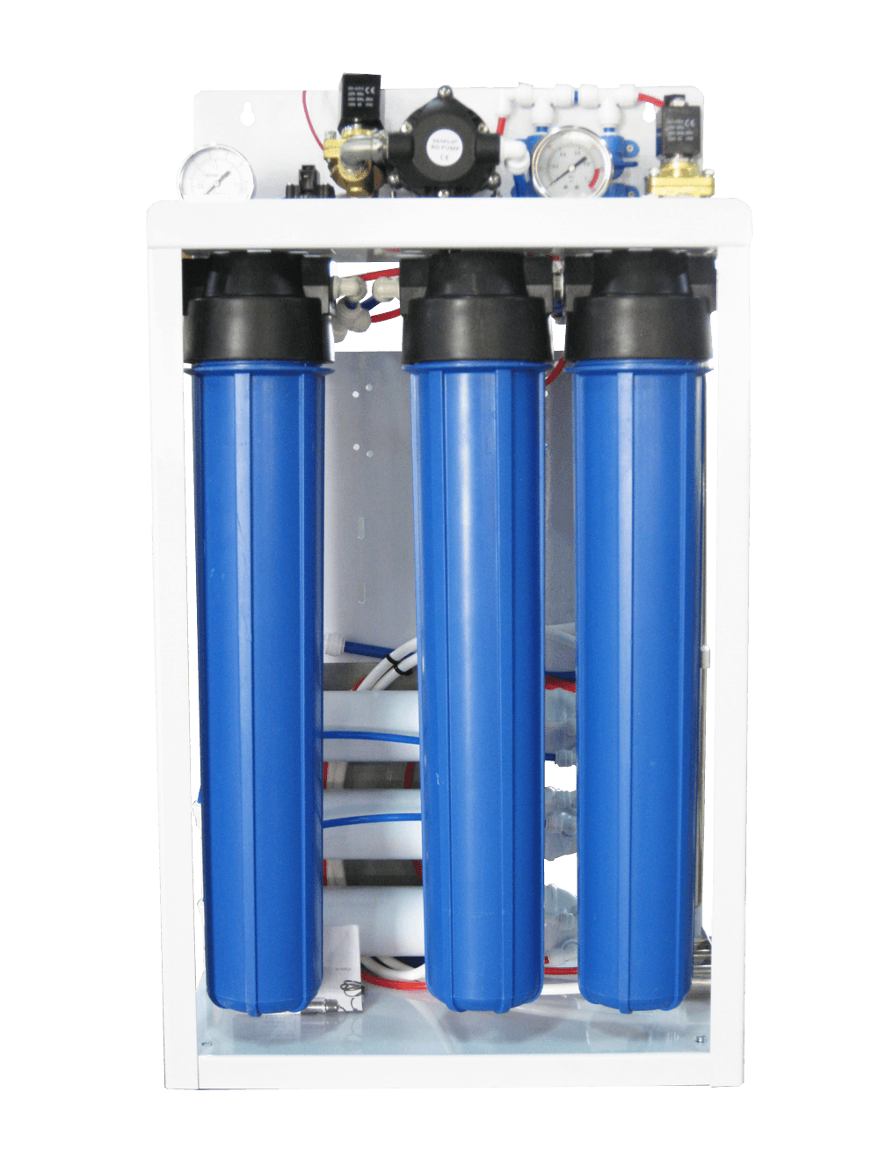
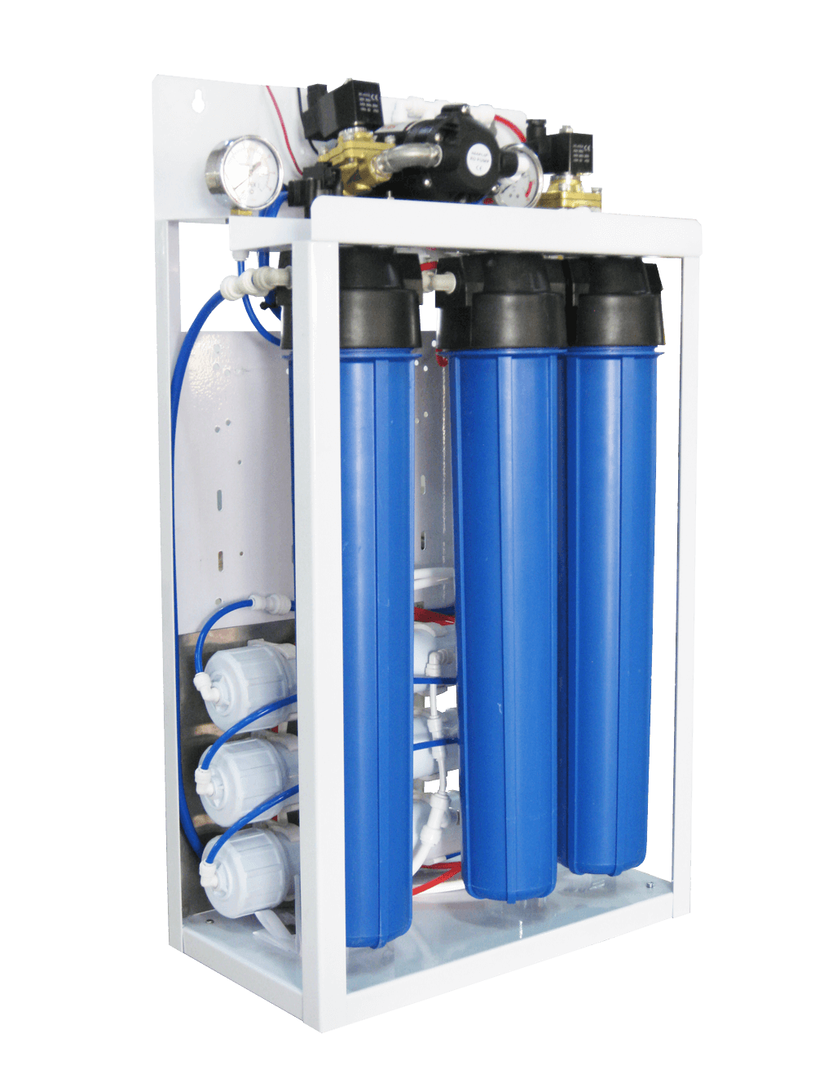

Reverse osmosis for small flow High quality, clean, 100% safe drinking water purifiers.
The high-performance water purifier with reverse osmosis water filtration system (also known as RO system) is the most purified water filtration system in the world (RO membrane. Has filtration resolution up to 0.0001 microns). Can remove impurities in water, including 99.99% of germs. The principle of reverse osmosis is to filter out impurities as well as various pathogens. Which is greater than the porosity of the membrane so that it cannot penetrate.

Suitable for those who want to use reverse osmosis water in small and extended families. With tap water or ground or brackish water and suitable for industrial installations using ground water or other sources or water used in the food industry. In addition, we can also customize the backward osmosis water purifier system to have the capacity of all sizes as desired. Let us know your needs.

Specification:

Inlet / outlet: 1/2″ NPT female.
- Voltage: 220VAC; 50hz
- Consumption: 140Watts (max.)
- Water discharge: 50-50%
- Feedwater requirements: 5 liters/minute at 1bar
- 1x 25-micron sediment filter, “2.5 x 20” cartridge.
- 1x 5-micron activated carbon block filter, “2.5 x 20” cartridge.
- 1x 1-micron sediment filter, “2.5 x 20” cartridge.
- Booster pump booster, 24VDC; 6A
- Low-pressure switch
- 3x TFC R.O membranes, 2.5 ” x 12″
- A water supply solenoid valve, 24VDC
- A flushing solenoid valve, 24VDC
- A concentrate valve
- A recycling valve
- Water pressure gauges
- 24 VDC power supply
- Painted steel structure.
- Dimensions 81 x 45 x 21 cm.

Delivery & Installation:

- Delivery and Installation will be within 50 to 60 working days upon placement of the order.

Warranty:

- Unless otherwise specified, the goods are guaranteed from the date of purchase against any manufacturing defect for a period of 12 calendar months.
- UV lamps, probes ORP, PH, injection pipes, pumps, dosing/circulation/ozone injection, ions generator are parts subject to wear, and the warranty is six (6) months.
- No warranty is provided for consumables.
- The warranty does not cover breakage of the lamp and the quartz glass.
- The Company shall expressly reject any warranty claim resulting from tampering by unauthorized Technician.
- Repairs and Maintenance services can only be performed by and Authorized TheNicheBPO Technician during the warranty period.
- Services pertaining to repairs shall be included during the Warranty Period.

