


BROCHURE

SWISS-THAI Wastewater Filtration Solution
with AFM® Technology Unit
Portable/Modular Wastewater Filtration System
Model: SWISS-THAI Customized 2,304CMB SYSTEM

(Production: 2.304Million liters per day / 96,000 liters per hour)

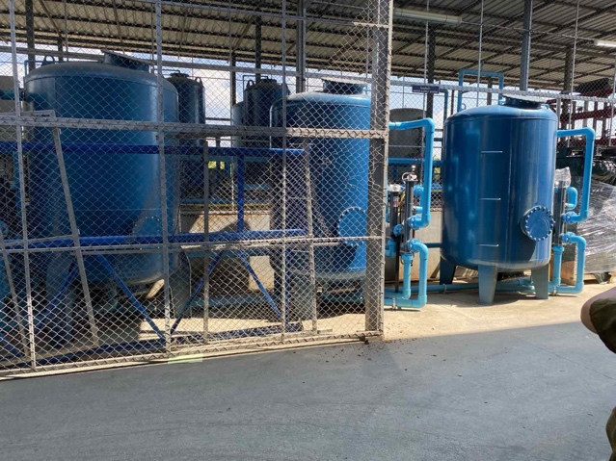

Specification:
- 3 Units - Swiss-Thai 768cbm Module in Parallel
- Size: L120m x W20m x H20m
  - Each unit consists of the following:
    - 190cm x 190cm AFM Filtration Unit
    - 1 Unit Injection Kit for Coagulant and Flocculant
    - 1 Unit Injection Kit for Sodium Hypochlorite
    - 1 Swiss Technology Automatic Backwash Module
    - Equipment for Monitoring Injection Set
    - Fully Automatic Control Box
    - 640W UV Sterilizer
    - 1 Unit Wastewater Inlet Pump with 7.5KW Motor (3 phase 220VAC / 60Hz)
    - 1 Unit Backwash Inlet Pump with 15KW Motor (3 phase 220VAC / 60Hz)



Additional features:

- Multi-Spectrum Coagulant and Flocculant (MSCF) for eliminating manganese iron color, Clear up cloudy water. (Include dosing pump, injector, PLC for control Injection, an injection pipe. All assembly in the waterproof control box and install in the system. Innovative high-efficiency wastewater filtration system, integrating PRE-FILTRATION + Injection Kits + UV wastewater treatment techniques in a single system.

- This combination of technologies uses high quality water filters. It is 40 times more efficient than a sand filter, it can filter heavy metals such as iron, manganese, chromium, phosphate, etc at 1 Micron.
- Incorporates a UV sterilization system to effectively kill bacteria and viruses.
- Can be integrated into proprietary technologies such as UF, Nano and RO System.
- The system is designed with the following:
  - Portable / Modular
  - Scalable / Cascadable
  - Long Life Glass Filters
  - Low Power Requirement
  - Resilient
  - Economical
  - Rapid Deployment

Delivery & Installation:

- Delivery and Installation will be within 50 to 60 working days upon placement of the order.

Delivery & Installation:

- Unless otherwise specified, the goods are guaranteed from the date of purchase against any manufacturing defect for a period of 12 calendar months.
- UV lamps, probes ORP, PH, injection pipes, pumps, dosing/circulation/ozone injection, ions generator are parts subject to wear, and the warranty is six (6) months.
- No warranty is provided for consumables.
- The warranty does not cover breakage of the lamp and the quartz glass.
- The Company shall expressly reject any warranty claim resulting from tampering by unauthorized Technician.
- Repairs and Maintenance services can only be performed by and Authorized TheNicheBPO Technician during the warranty period.
- Services pertaining to repairs shall be included during the Warranty Period.

