BROCHURE

SWISS-THAI Wastewater Filtration Solution
with AFM® Technology
Portable/Modular Wastewater Filtration System
Model: SWISS-THAI OZONE-PHFC (Commercial/Industrial)

WATER PURIFICATION – pre-treatment high FLOW Filtration – COMPACT (PHFC)

Sediment filter, UV, UF (ultrafiltration), ozone, reverse osmosis and activated carbon
High Flow Pre-Treatment Drinking Water

(Production: 5,000 liters per hour / 120,000 liters per day)

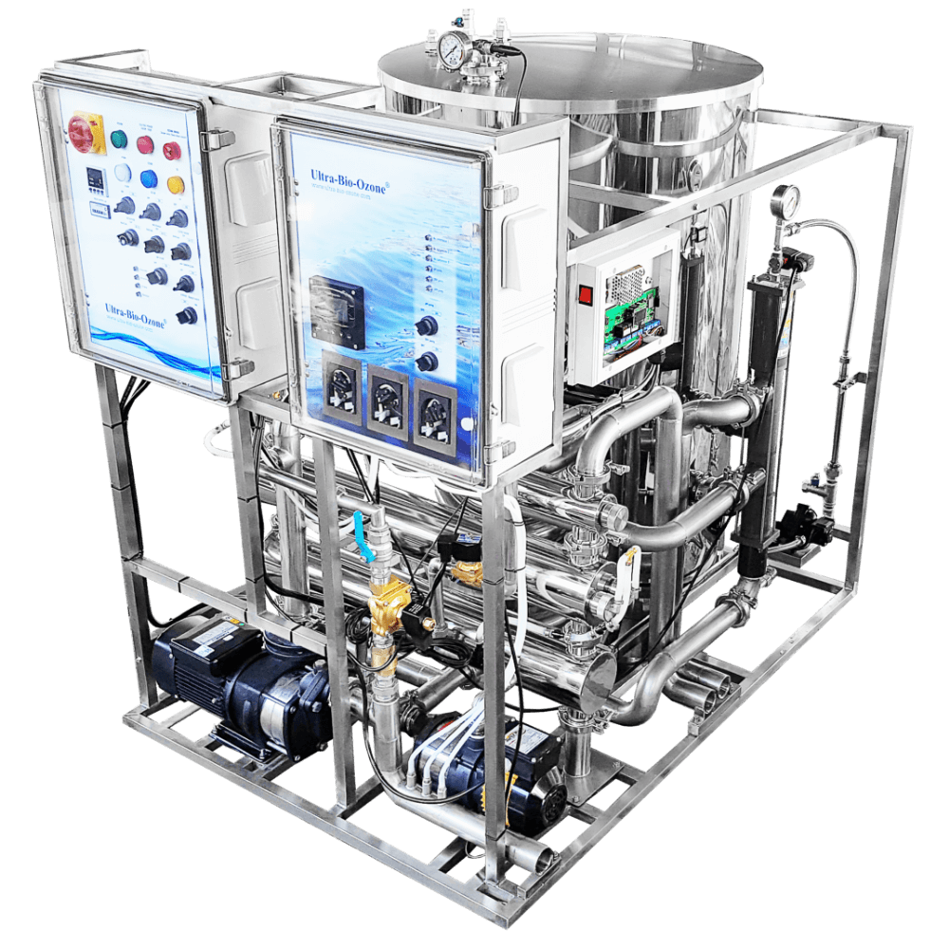
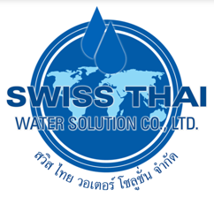


Specification:

High flow Pre-treatment – Water purification process:
- Media filtration
- Ozonation
- UV sterilization
- Peristaltic pumps:
  - injection of a flocculant solution

  - injection of a pH solution
  - injection of chlorine solution


Adaptable according to the quality of the incoming water

Filter media tank activated
- Stainless steel, grade 304
- Diameter: 77.5 cm
- Height: 122 cm
- Thickness: 2mm

Ozone generator and UV sterilizer
- Stainless steel case
- An amalgam UV sterilizer
- 105W 1200mA
- lifespan: 13,000 hours


Three peristaltic pumps
- injection of a flocculant solution
- injection of a pH solution
- injection of chlorine solution

Controller and monitoring
- A pH / ORP control unit
- Voltmeter monitoring
- An Internet surveillance system.

Dimension :
- L 101 cm x P 97 cm x H 93 cm

Dual ozone injection mode.
- Normal mode
- Ozone shock mode

Delivery & Installation:

- Delivery and Installation will be within 50 to 60 working days upon placement of the order.

For Inquiries please call: 0917-541-2188 / Edmond Antonio

