BROCHURE

SWISS-THAI Wastewater Filtration Solution
with AFM® Technology
Portable/Modular Wastewater Filtration System
Model: SWISS-THAI OZONE-MFC
(Commercial/Industrial Application)

WATER PURIFICATION – MEDIUM FLOW filtration – COMPACT (MFC)
Water purification. Purifying water with ozone and ultraviolet light has advantages over chlorine or any other chemical, because the water is free of any residual product.
Drinking Water Medium Flow

(Production: 1,000 to 4,000 liters per hour / 24,000 to 96,000 liters per day)
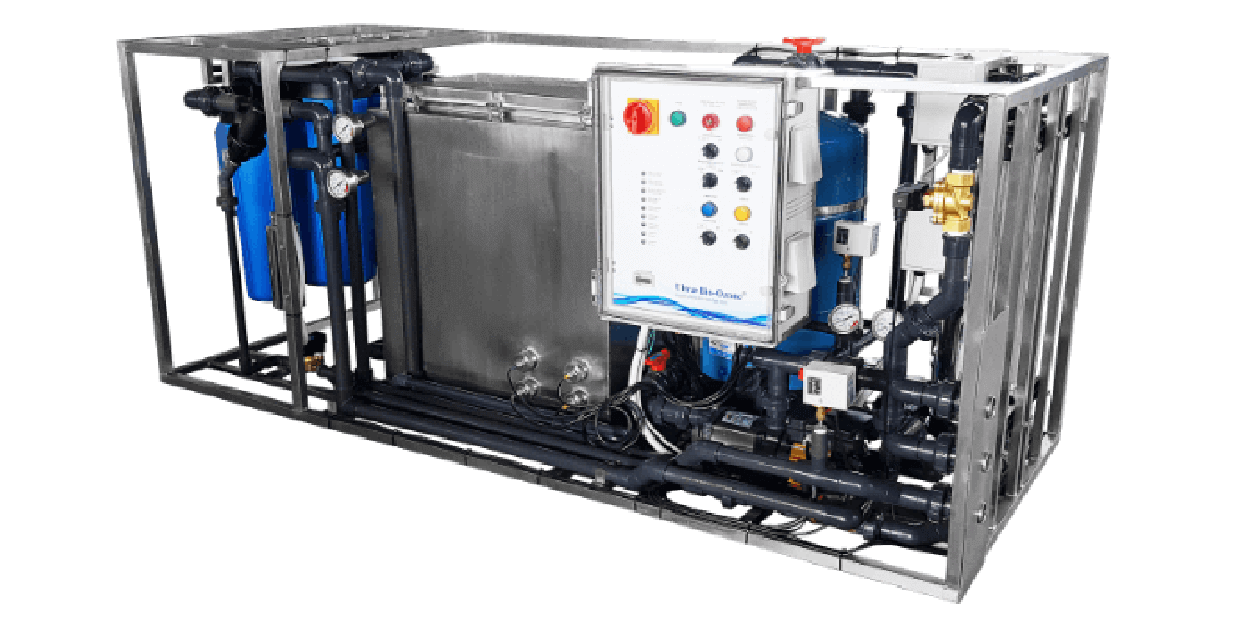





Specification:
- Dimensions: Length 190 cm, Width 77 cm, Height 90 cm.

- Weight: 300 kg.
- Treatment flow: Micro-filtration or ultra-filtration capacity
from 1000 to 4000 liters / hour.
- Filtration:
  - Self-cleaning prefilter
  - Microfiltration or ultrafiltration
  - Ozonization
  - UV-C treatment
  - Ozone destroyer
  - Patented injection for, for example, treating the water pipes after the system.
  - Charcoal

For water treatment :
- Houses with small and medium flows.
- In the food industry.
- Small hotel complexes and holiday structures.
- In agriculture, dairies, cheese factories, restaurants, etc.

Effectivity:
- Having a tandem with 2 treatment methods, OZONE and UV eliminates all forms of microbiological contamination.
- Ozone acts by oxidation via a rupture of the cell membrane in a few seconds of contact.
- UV rays exert a germicidal effect on microorganisms by inhibiting their reproduction or by destroying them.
- If the water is heavily contaminated, additional filtration can be provided as an option.

Economical:
- Power consumption only at the time of water intake.
Thanks to its complex and precise electronic management, it is only activated when the passage of water is detected. This intelligent operation prevents any risk of part of the flow escaping treatment. This distinguishes it from other UV-C water treatment systems that operate 24 hours a day because they do not have this expensive electronic management.
- The sediment filter with backwash guarantees operation without changing the filter media for a minimum of 5 years.
- The longevity of UV-C lamps reaches 10,000 hours.

Delivery & Installation:

- Delivery and Installation will be within 50 to 60 working days upon placement of the order.

For Inquiries please call: 0917-541-2188 / Edmond Antonio

