BROCHURE

SWISS THAI WATER SOLUTIONS
Portable/Modular Wastewater Filtration System
with AFM® Technology
Model: ECS I (Commercial/Industrial Application)

(Production: 600 liters per hour / 14,400 liters per day)



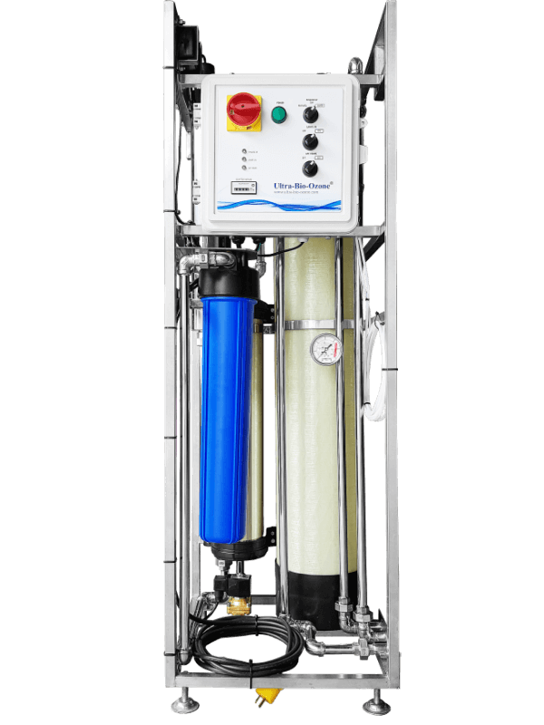

Specification:
- Weight: 58 kg
- Size: L46 x W43 x H135 cm.
- One Activated filter media tank with “Manual or Automatic Backwash”
  - Fiberglass tank 8″ x 44″ (20.32 cm x 111.76 cm) ,
complete with manual backwash valve.
  - Filled Performance filter media, Total 21 Liters (25 Kg)
- One UV sterilizer, 25 watts, 220 Vac 50/60 Hz
- UF filter completed a with the automatic flush valve.
- One post carbon block filter, 2.5″ x 20″ (6.35 cm x 50.8 cm) cartridge length.
- One water flow meter.
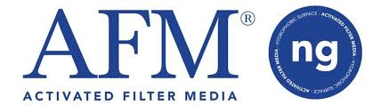
- One water pressure gauge.



Additional features: (Optional)

- Multi-Spectrum Coagulant and Flocculant (MSCF System) for eliminating manganese iron color, Clear up cloudy water. (Include dosing pump, injector, PLC for control Injection, an injection pipe. All assembly in the waterproof control box and install in the system).

Innovative high-efficiency water filtration system, integrating PRE-FILTRATION + ULTRAFILTRATION + UV + activated carbon water treatment techniques in a single system.

- This combination of technologies uses high quality water filters. It is 40 times more efficient than a sand filter, it can filter heavy metals such as iron, manganese, chromium, phosphate, etc…
- Incorporates a UV sterilization system to effectively kill bacteria and viruses.
- Ultrafiltration (UF) can filter down to 0.01 micron using a membrane to separate undesired materials. It filters bacteria and particles present in the water. Ultrafiltration (UF) technology is particularly popular in industrial applications.
- The activated carbon filter absorbs chemicals, odors, residual chlorine, heavy metals such as lead and copper, insecticides, detergents and high carbon products.

Delivery & Installation:

- Delivery and Installation will be within 50 to 60 working days upon placement of the order.

For Inquiries please call: 0917-541-2188 / Edmond Antonio

