BROCHURE

1 UNIT SWISS-THAI Wastewater Treatment Solution
with AFM® Technology Unit
Model: SWISS-THAI OZONE-HFC (Commercial/Industrial)

WATER PURIFICATION – high FLOW Filtration – COMPACT (HFC)

Sediment filter, UV, ozone and peristaltic pumps for possible chlorine residual injection
Drinking Water High Flow

(Production: 2,500-6,000 liters per hour / 60,000-144,000 liters per day)

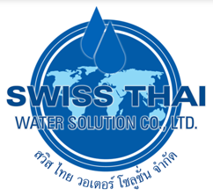

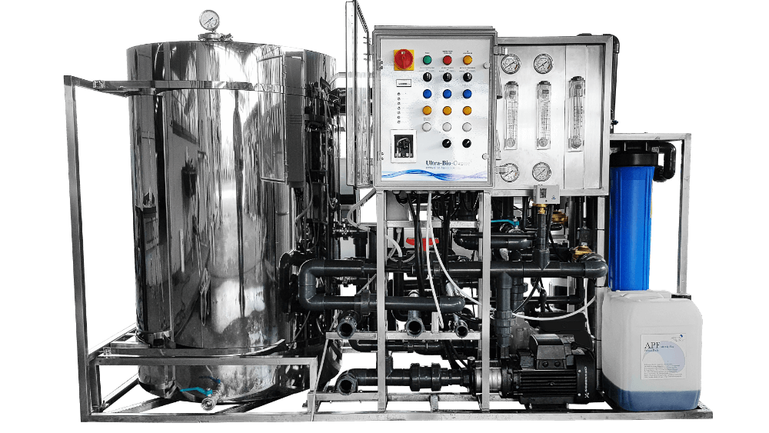

Specification:



Drinking water high flow – Water purification process:
- Media filtration
- Ozonation
- Ultrafiltration membrane (s)
- Nanofiltration or reverse osmosis membrane (s)
- UV sterilization
- Charcoal
- Adaptable according to the quality of the incoming water

Filter media tank activated
- Material: stainless steel, grade 304
- Filter media filled: 405 kG (341 liters)
- Filtration speed: 15 m/h

Ozone generator and UV sterilizer
- Three ozone lamps 80W, 800mA
- Stainless steel case
- 220Vac 50 / 60 Hz, 240W

Hollow fiber membrane
- Membrane material: PVDF
- Pore size: 0.03 micron
- Flow type: outdoor
- Maximum flow 6 m3/hour

Active membrane (2)
- Permeate flow: 8,000 GPD
- Operating pressure: 70 PSI
- NaCl release> 85%, MgSo4 release 99%

Energy consumption :
- Water production: 3,063 Watts/Hr (Max.), 13 A.
- Backwash operation = 2,600 Watts/Hr (Max.), 11.8 A.

Delivery & Installation:

- Delivery and Installation will be within 50 to 60 working days upon placement of the order.

For Inquiries please call: 0917-541-2188 / Edmond Antonio

