BROCHURE

1 UNIT SWISS-THAI Wastewater Treatment Solution
with AFM® Technology Unit
Model: SWISS-THAI ACS II (Commercial Industrial Application)

(Production: 1,500 liters per hour / 36,000 liters per day)

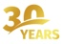
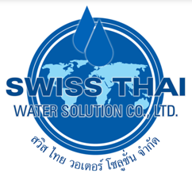
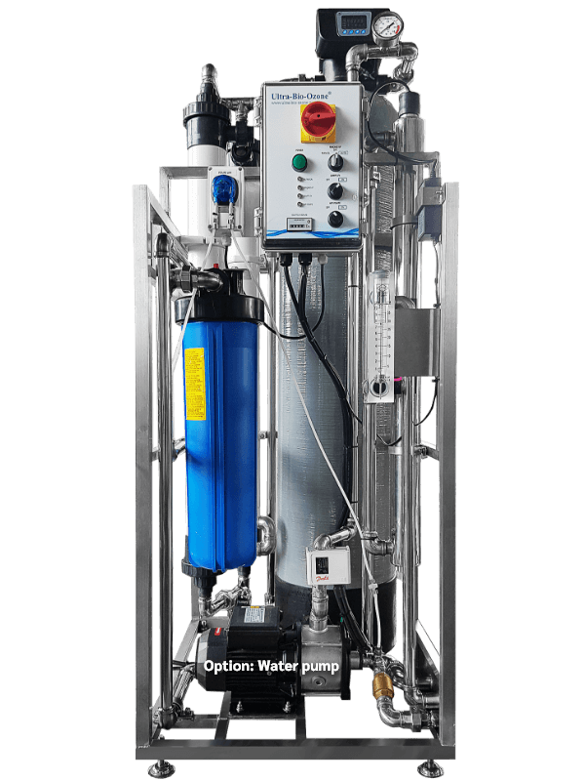

Specification:
- Weight: 108 kg
- Size: L84 x W62 x H158 cm.
- An active media filter tank with “Manual or Automatic Backwash”
- 12″ x 52″ (30.48 x 132.08 cm) fiberglass tank.
- 55 watt UV sterilizer, 220 Vac 50 / 60 Hz.
- UF filter with a flush valve
- 4.5″ x 20″ (11.43 x 50.8 cm) activated carbon filter.
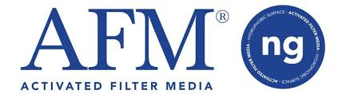
- water flow meter.
- pressure gauge.

- Power: 50W/h Maximum

Additional features: (Optional)

- Multi-Spectrum Coagulant and Flocculant (MSCF) for eliminating manganese iron color, Clear up cloudy water. (Include dosing pump, injector, PLC for control Injection, an injection pipe. All assembly in the waterproof control box and install in the system. Innovative high-efficiency water filtration system, integrating PRE-FILTRATION + ULTRAFILTRATION + UV + activated carbon water treatment techniques in a single system.

- This combination of technologies uses high quality water filters. It is 40 times more efficient than a sand filter, it can filter heavy metals such as iron, manganese, chromium, phosphate, etc…
- Incorporates a UV sterilization system to effectively kill bacteria and viruses.
- Ultrafiltration (UF) can filter down to 0.01 micron using a membrane to separate undesired materials. It filters bacteria and particles present in the water. Ultrafiltration (UF) technology is particularly popular in industrial applications.
- The activated carbon filter absorbs chemicals, odors, residual chlorine, heavy metals such as lead and copper, insecticides, detergents and high carbon products.

Delivery & Installation:

- Delivery and Installation will be within 50 to 60 working days upon placement of the order.

For Inquiries please call: 0917-541-2188 / Edmond Antonio

